109550194 龍偉亮

NSCAP Final Report : Mobile IP

# Expected Results

If things go well, I hope the simulation can behave as closely to the protocol as possible. With visualization already mostly implemented in the OSPF homework, when a certain end host A tries to send a packet to another end host, let’s say B, who has temporarily moved out of its home network and is now in a foreign network registered to an agent. The packet should be forwarded to the home agent, which is then forwarded to the foreign agent and to end host B.

And when B wants to send out a packet, the packet should follow the shortest path possible to the destination.

# Actual Results

## Setup 1

The setup in the screenshot follows the topology in the illustration above.

Nodes:   
 3 routers : 5, 6, 7  
 2 hosts : h1, h2  
Links:  
 5-6 : Cost 1  
 5-7 : Cost 1  
 6-7 : Cost 3

With h1 currently set to router 6 as HA,  
and h2 to router 7 as HA.

Now we attempt to send a packet from h2 to h1

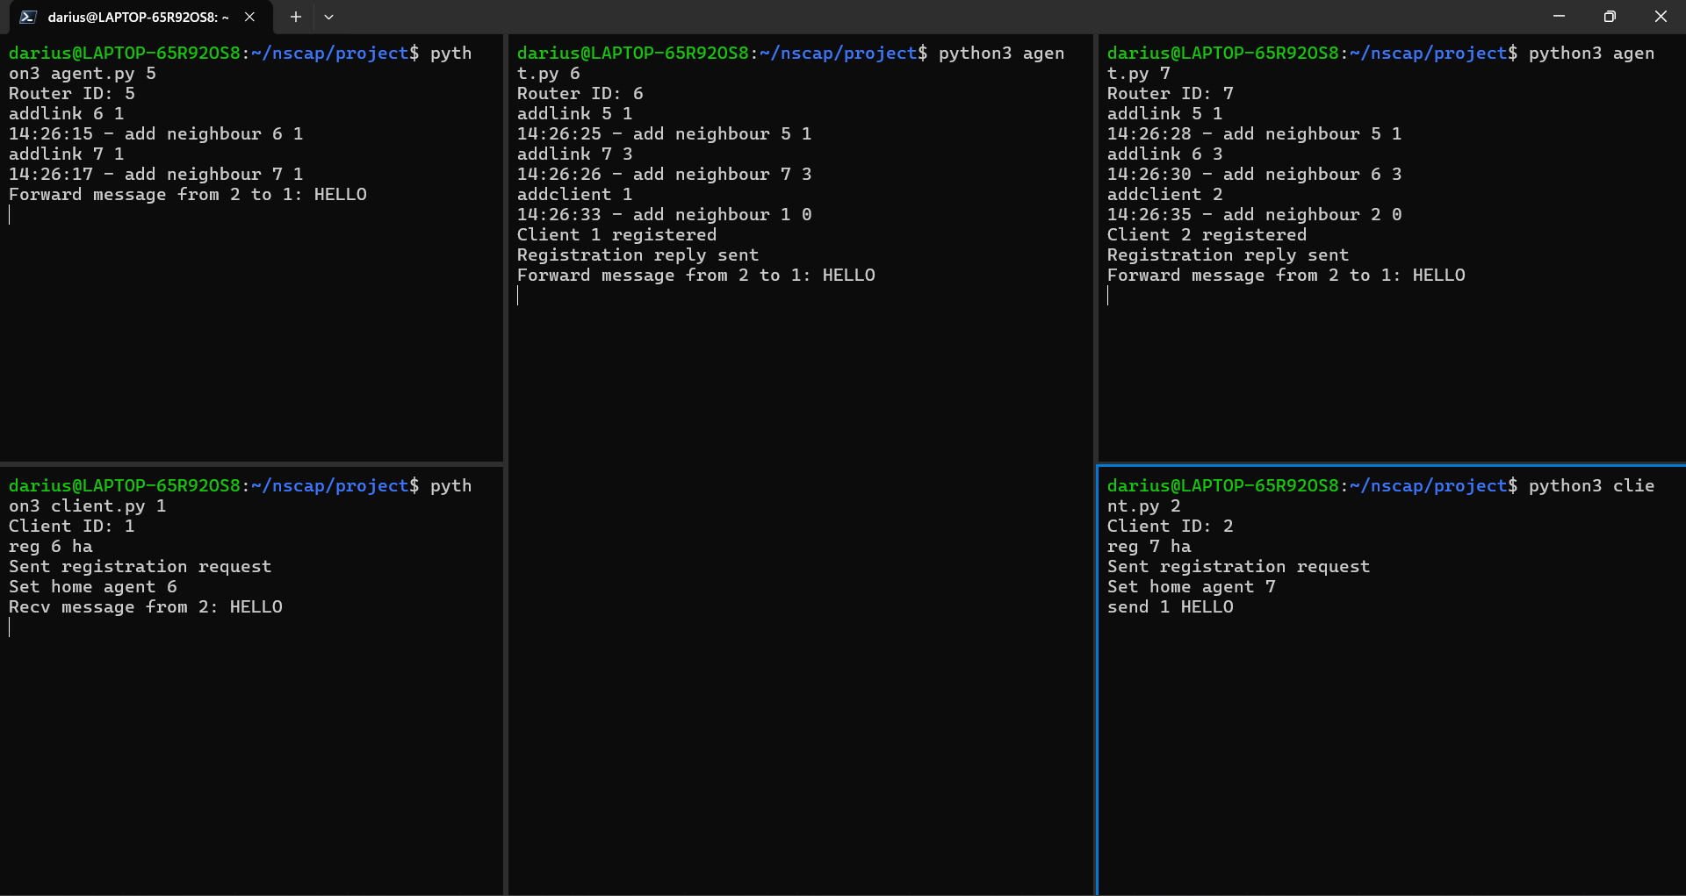

We can see that the packet follows the pathway as shown in the illustration.

The packet follows a normal shortest route to the HA of h1, then it forwards the packet to h1 as they are currently still in their home network.  
Sending a packet from h1 to h2 follows the inverse of the same pathway.

Now we let h1 move outside of its home network, and register router 5 as its FA.

It can be observed that once h1 registers with router 5 to be its FA, a packet is sent to router 6 (HA) to notify of their care-of-address which is currently router 5.

Now we attempt to send a packet from h2 to h1 again,

We can see that as the packet followed the same pathway as before h1 moved out of its home network, the packet is sent to its HA (router 6).  
But now router 6 knows h1 is on the move, in other words somewhere connected to the device with its care-of-address (CoA). The HA will create a tunnel for the packet, directed at the CoA (router 5).  
Now router 5 receives the packet from the tunnel, it will decapsulate the tunnel headers and forward the original packet to h1.

And then we try h1 to send another packet to h2

The packet follows the shortest pathway without having to go through its HA or any tunnelling, directly to h2.

## Setup 2

In this setup, both hosts will be away from their respective home networks. And in the middle is a bottleneck of two routers 21 and 22 without agent capabilities.

We attempt to send a packet from h1 to h2

As we can see, the pathway of the packet first gets sent to the HA of h2 on router 12,  
router 12 receives the packet and determines it should tunnel the packet to the CoA which is currently router 14.

Despite having on agent capabilities on routers 21 and 22, their only job is to calculate routes and forward packets, so it works regardless of where they are in the topology.

And if we look at the red circled area in the screenshot, router 21 first stores and forwards the packet to router 12, it is a normal packet with the message “IAMSODAMNHUNGRY”. But the second time it appears on router 21, the message content becomes “1,2\nMSG\nIAMSODAMNHUNGRY” which should be the original headers and message. This packet was tunnelling through router 21, so it makes sense if the tunnelled packet was encapsulated in another layer of headers.

If we try to send a packet from h2 to h1

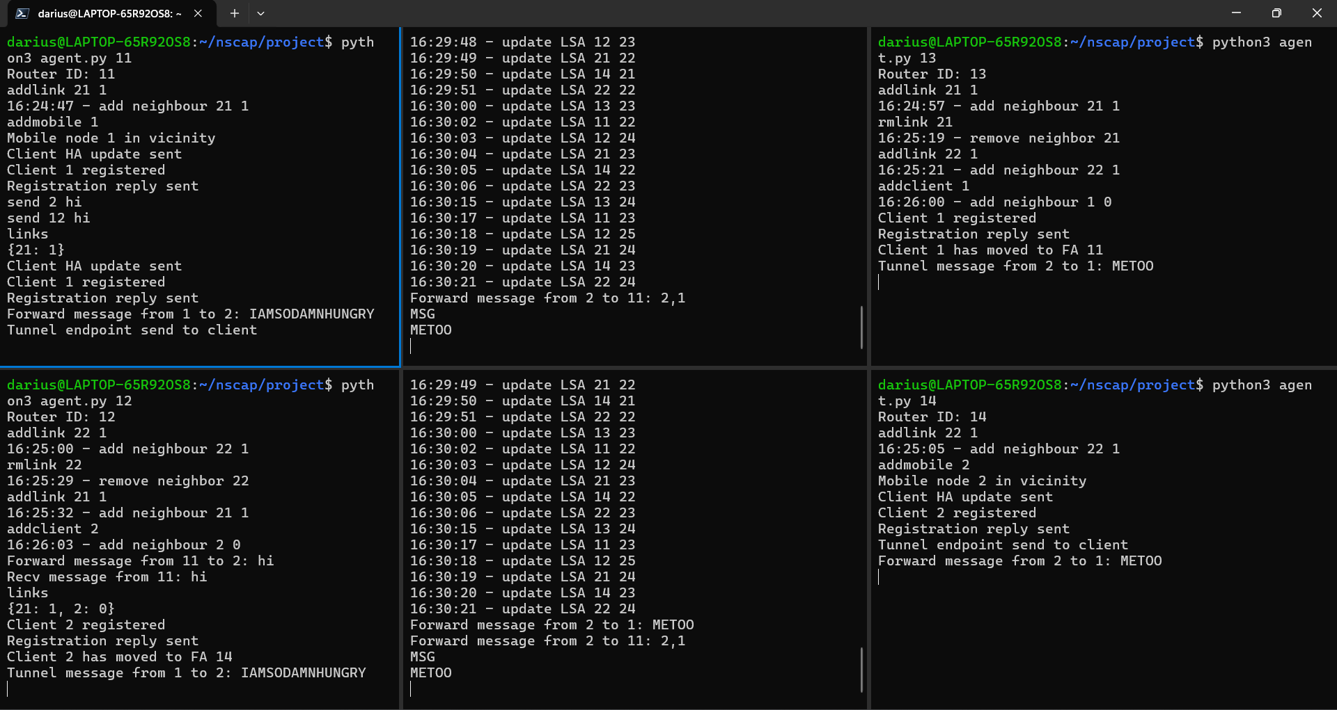

A similar scenario happens whereby forwarding and tunnelling will happen in the routers to forward the packet from h2 to h1.

# Expected vs Actual Results

Initial expectation for this experiment was to have the packet pathway and behaviour to be as close as possible to the Mobile IP protocol. This experiment was built on top of the OSPF routers from homework 4, and with the aim of backwards compatibility to the original router programs.

Results show that the packet indeed does follow expectations. To summarize the operation of this protocol, mobile nodes will each register with a home agent in their respective home networks. When they move into foreign networks, they can register with foreign agents, sending registration request with their respective home agent address. If the foreign agent acknowledges the mobile device, a reply is sent and an update packet is sent to the home agent to notify of the current care-of-address for the corresponding mobile device.

The address of the mobile device remains unchanged from the perspective of the routers in the network. Any packet meant for the device would be sent to its home network, before being intercepted by its home agent, then either tunnelled or forwarded if the device is in its home or a foreign network.

But in trying to achieve backwards compatibility, it was found that my method of implementation makes it so forwarding in the original OSPF router programs becomes a problem. Because my implementation uses packet type TUN and AGENT to direct tunnelling and agent update packets. Therefore, to make the original routers work, slight modifications have been made to detect these two types of packets.

All in all, the results obtained in this experiment follow very closely to expectations. But slight modifications have to be made to achieve backwards compatibility, which kind of destroys the mission.